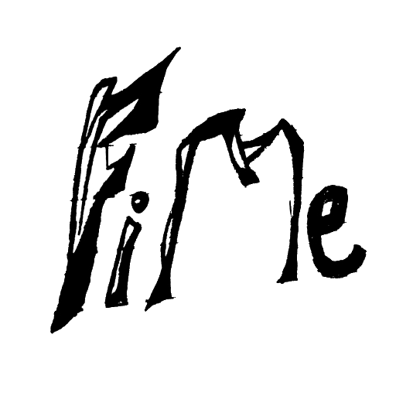

CODE

Authors: Chiranthan Mirle - 1001011399

Abhishek Agarwal - 1000987331

Ranjith M A - 1000969864

Ather Mohammed - 1000993284

Bhavana Nandyala - 1000859140